**Create business Readable Modules from the exported results of API Scan**

1. API Modules: 🡪

* Contains Technical information imported from API Scan

1. Business Parameters: 🡪

* Business Params are elements from Scanned code used in the Testcase (not same as business parameters we used in reusable teststepblock)

1. Action Modes: 🡪

* Determines what Tosca will do with the business parameters while they are being tested
* In modules, API scan will create 2 modules for every API service
* GET service will have 2 modules create (request and response) as both will have different messages
* In Teststep it follows same structure as API scan
* Recommended, rename testcase
* Get familiar with Test configuration parameters

Before

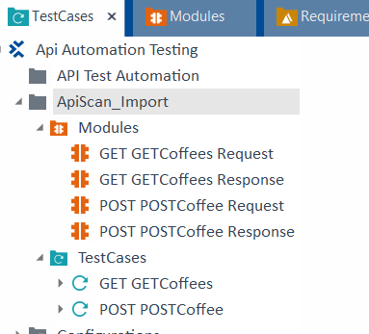

After **********************************

* Every thing is SAME as UI module just the technical view is API scan is not available in UI module

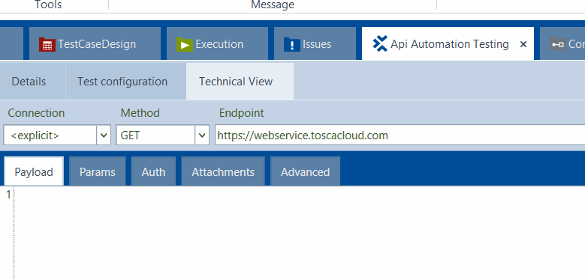



* Technical View tab is same as API scan view



**API Modules**

* The contents of the Modules are similar to the Request and response of the related API message
* Request and Response are independent from each other in Tosca, meaning that different business parameters can be added to each module
* Recently created Teststeps are similar to the once created using modules from Xscan in previous lessons of AS1
* Business Parameters will update Automatically whenever there is change in API scan message, covered further

Steps: 🡪

* Select Shop messages (POST, DELETE, GET) and export it
* Then move all the teststeps into one folder and rename it
* Bcz we have to run all teststeps in 1 testcase

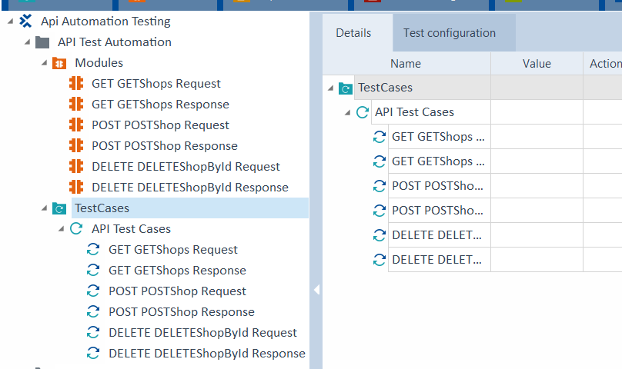

* Create business Parameters for these modules
* BP – Business related elements of a messages (name, id, address)
* BP remove the need to look at the complex coding of API. Therefore, it is easier to explain to a non-technical user exactly what teststeps are intended to do
* Recommended way to create BP is using technical view tab. Lets create BP for module 01 create Shops
* Select Parameter and click button to add in the ribbon to create BP

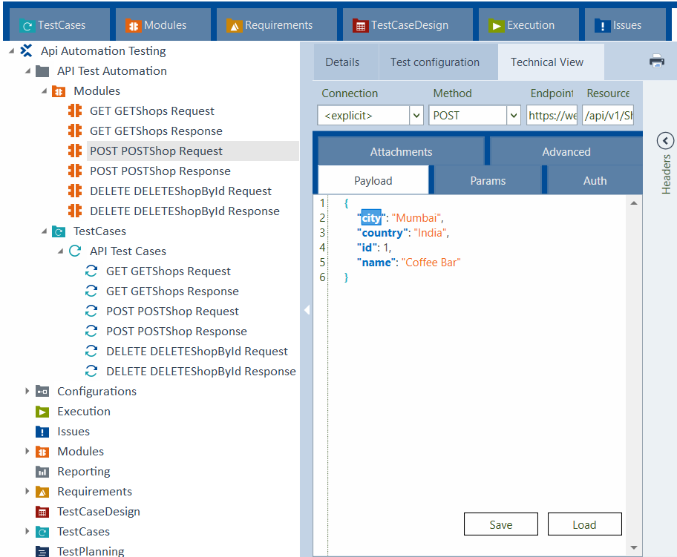

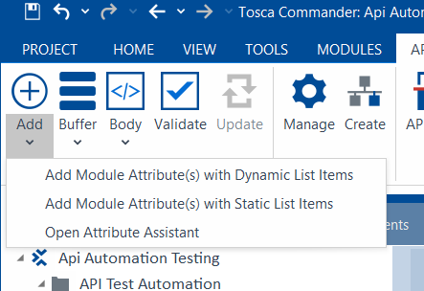

* As soon as we click on Add button, BP city is added to the module

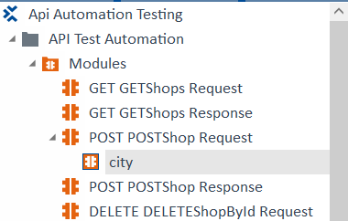

* No need to select complete line, just select part of the line
* Additionally, if entire block is select and added then multiple BP will be added at once
* We can also add BP for Status code also or anything like that also
* Any component we want to add as our business parameters we can add
* Any Part of technical view can be added as BP
* Response Time
* Method
* Endpoint
* Individual Rows in Parameters
* Header

**Best Practice**

* Any changes made in API Scan will not synchronize with modules or Testcases imported into tosca, after they have been exported
* Changes will need to be updates manually or using update button in the API home menu

Consider: If something on the server within the API changes then BP and relevant Testcases has to be updates

Otherwise, if we run the testcase in scratch book it will fail

Ex. In post shop “city” word is changes to “town” in the message

* Just change it into the message
* Select and click on Update

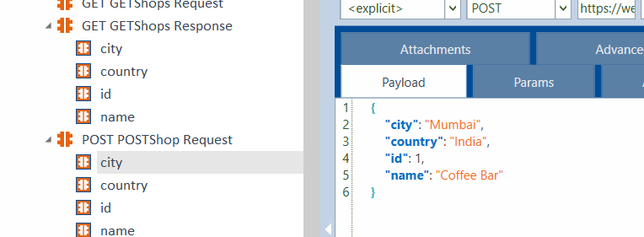

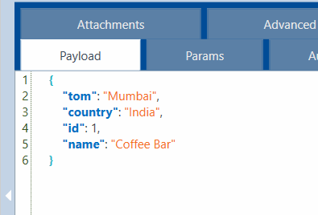

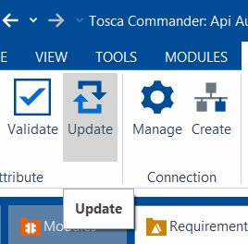

* This will update the technical info of the modules and the testcases automatically
* Update Button: update changes made to the API Scan after it has been exported to tosca